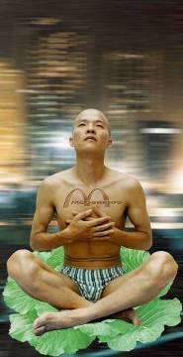 Thinker, 180x90cm, 1998

It is well known that McDonald's and Pizza Hut are just fast-food stores in Europe and America, nothing more than convenience. However, when they came into China, they became top cuisine and hot rendezvous for people to have parties, invite friends, celebrate birthdays and meet lovers. On the surface, this phenomenon of going after pop western style represents an ideal for Euro-American materialistic life. But in such an era of globalization, does this ideal also represent worship that can create a lot of ridiculous contradictions? With this thinking, I created many photographic works including “Thinker” (1998), “Prisoner” (1998), and “Catcher” (1998).

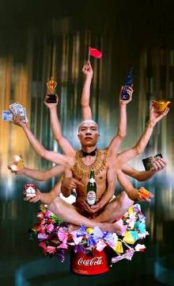Requesting Buddha Series No.1, 180x110cm, 1999

As the quintessence of Chinese traditional culture, Buddhism has accompanied Chinese civilization for thousands of years. It brings comfort and fortune to the people, inspires their soul and enlightens a responsibility for having good relations with the others. This Buddha used to set its goal to save the suffering through self-devotion. However, in the current commercial society, the respectable Buddha has also been changed. It reaches out its hands insatiably for money and material goods towards every troubled person. The “Requesting Buddha” Series （1999）is the faithful representation of such a phenomenon, overflowing with desires, hypocrisy and exaggeration.

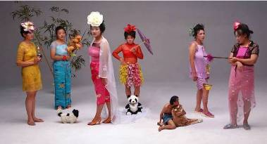 New Women, 120x220cm, 2000
“Court Ladies with Flowers”, a classical piece in Tang dynasty, described the decadent life in the imperial court. However, such desperate and dissolute lifestyle was not exciting, since it was separated from the then social realities. Such ecstasy was only playful fun scenarios designed by the noble rich people. That is the reason I revisit this painting. With the rampant consumerism going on that promulgate pop culture, we see a lot of fake novo-riche who dress themselves with jewelries and fashion brands. They look fabulous, confident and happy. But inside their heart, they must feel very timid that their hard-earned business and treasures shall end in bankruptcy. It is very obvious why I entitle this work as “New Women”. When women were liberated, they are confronted with harsh requirements. They need to have a fantastic outlook, sustainable heart, engaging in all tough positions and confronting with varieties of difficulties. In fact, these exposed appearances are fake and fabricated. Loads of sufferings hide behind. Are they really the contemporary modern women?

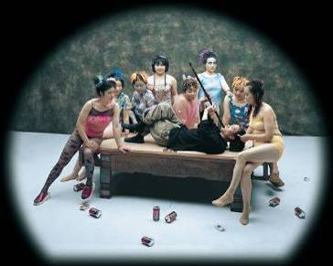 Finding Fun, 120x150cm, 2000年
“Finding Fun” looks like inspired from an old painting. In fact, it was created based on my observations of both the past and present social and life experiences. It is a concentrated reflection on the empty-mindedness I feel about contemporary people who work to make more money. But money never can buy happiness. Nowadays the most popular term is finding fun. In order to tint this work with sentiments and indifference similar to that of the old literati, I change the color of the photo into cold one in order to stress the hypocritical and disillusioned psychology in peoples mind.

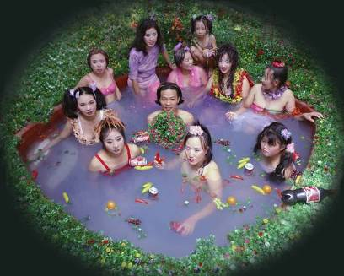 Bath House, 120x150cm, 2000
I remembered that when I was a child, I often went to public baths together with other boys because most families did not have such facilities back in home. Bathroom was the place where children played and had fun. I even swam in the bathtub. When I grow up, China has experienced dramatic changes through opening-up and modernization. People’s life has been improved. Many rich families install bathroom and electric or gas water heater at home. The public bathhouses have gradually disappeared from our life. However, they are reconstructed and decorated by people who have an eye to their commercial values. The past public bathhouses reappear as Bath Center where services of all varieties are offered, such as bath, foot nail-clipping, massage and dining as well as Karaoke, and other forms of entertainment. They become a new spot for consumption. Rich guys even go there for discussing negotiations, signing contracts and having parties. Of course bathhouses are abused as places for sexual trade since it is the easiest way to make huge amount of money. Such businesses go very faddish not only in the entertainment industry, but also in fields such as urban construction, culture, and etc. These phenomena seem to be very common. They are so weird and abnormal which exist in contemporary China. This is the reason and significance that I set up a spa setting and invite female models to shoot Bath House.

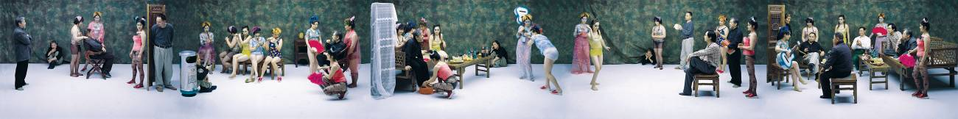
Night Revels of Lao Li, 120x960cm, 2000

What has been haunting in my mind is the position and destiny Chinese intellectuals experience in our history. In such an era that lacks ideals, people have cast doubt on the heroes and ideals of the past. I wanted to catch some scenes that describe such loss of hopes replaced with hoarding desire for money and power. To compare the past and present, I appropriated the old and known masterpiece “Night Revel of Han Xizai” which was the best piece of Chinese traditional figure painting. This old art piece reflected the then social life in the torrents of transformation, and depicted the life of a worried intellectual and high official in Post-Tang Dynasty, Han Xizai. He was powerless to fulfill his ideals of reconstructing the country. To “cleanse” himself, he chose to evade and “indulge in” comfort. After several centuries, even though the Chinese dynasties have changed frequently, the status of intellectuals in society has remained the same. With some thoughts on this question, I created “Night Revel of Lao Li”. It is a portrait of contemporary Chinese reality in this new century, portraying the situation of contemporary Chinese people, and of intellectuals in particular.
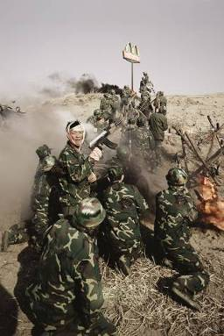
Another Battle Series No.6, 180x120cm, 2001

“Another Battle” Series (2001) is influenced by the snapshots of patriotism and heroism extolled in the old movies talking about safeguarding the motherland that I watched in childhood. The heroes gave their lives for the liberation of new China in movies like “Landmine War”, “Guerrilla War”, “Three Liberation Wars”, etc. I used to dream about becoming a soldier, too. Up until now, this dream has not been realized. Nowadays economic reconstruction is like a war that progresses so rapidly and intensely. In this war, we have to face contradictions from both Chinese ancient civilization and modern western civilization. I call these contradictions Another Battle. In this battle of “defending our country”, without fire and gunshots, I portray myself as a defeated commander. It looks there is no winner at all in this battle.

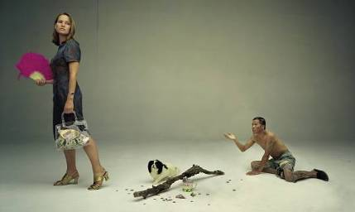 Beggar, 120x200cm,2001
The most striking thing in the streets of Beijing is that we often see beggars loiter around foreign embassies and consulates where rich people of Chinese or foreign descent, come and go. The beggars ask for small changes. When I came to Beijing and saw such a weird thing in 1993, I felt very depressing. So I did a performance, called Beggar. For three days, I walked on the street in Sanlitun, where foreign embassies and bars were located, and asked for money from foreigners only and did not give any reasons when they asked. However, I failed. I did not get any money. I did not get any sympathy either. In 2001, I reshot this memory through the shutter of camera and called it Beggar. However, it gave a different direction. Besides the value significance we give to paper currencies, I want also to satirize the pompous attitude the rich give to the poor.

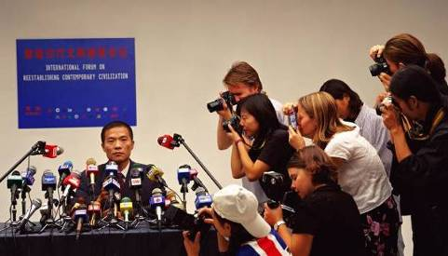 Forum, 120x210cm, 2001
Forum was triggered off by the “achievements” China made in 2001. All people were so happy because first, we entered WTO; second, we were granted with the right to host Olympics 2008; third, Chinese football team stroke into the top 32 teams. All these achievements seem to give us more confidence that we are becoming much stronger. Therefore many cosmopolitan cities organize international forums on environment, population, economic growth, and etc. This work intends to give my attitude towards the superficial way to making something big.

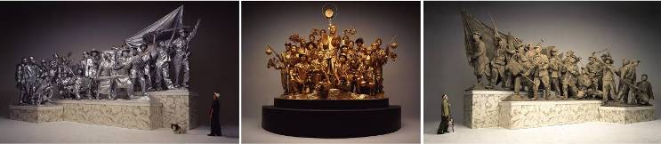
Past, Present and Future, 170x(283+212+283), 2001

To keep track of my reflection upon our past, consideration of our present and depiction of our future, I find the urban sculpture best reveals our history and ideal. However, I pose some doubts on what we have achieved and what we are expecting. With such “doubt”, I portray myself as a bystander in the triptych work entitled “Past, Present, and Future” (2001). Models are smeared with mud, silver and golden powder hinting at the changes in time from the revolutionary times to the modernization age, and onto the future we are aspiring. The postures of the models imitate those on the monumental Communist sculptures still found in some cities in China. I hope this work achieves the effect of reflecting upon the history of the past, reconstruction of the present and beauty of the future.

Knickknack peddler
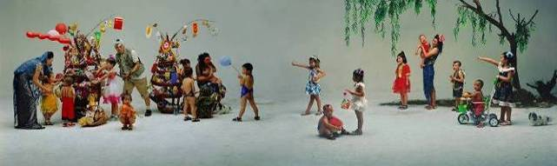 Knickknack Peddler,120x400cm, 2002年

Knickknack peddler has a very long history in China. Peddlers often go around in cities and countryside. They serve as a road to learn about the outside world since they spread information to the far countryside when there is no telephone, cable or email. Meanwhile, Peddlers could act as spies in Chinese revolutionary periods. Furthermore, there is a historical background to this painting. Many ancient painters have expressed their feelings towards life through describing peddlers. For example, the one, I worked on was taken from Song Dynasty that the painter wanted to express the joy of kids. I replaced the ancient stuff with modern popular food, brands, and etc. Maybe in the future, peddlers shall disappear from our society though it has acted a symbolic role to reconstruct the society. I envision peddlers will be replaced by supermarkets.

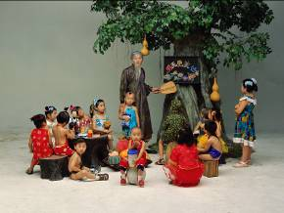 Preschool,120x160cm,2002
Continuing the idea of reflection upon our destruction of traditional culture, the gigantic models portrayed by three live persons tell humorously our ludicrous behavior of praising our precious past though unconsciously damaging the history. Such skewed beliefs can be also found in present education in China. Nowadays children are much geared towards obtaining popular goods and fashionable stuff. So in my "Preschool" which makes a parody of the ridiculous and self-contradictory beliefs and actions in Chinese educational system, I am reconsidering what effect the slogan that education should start off from kids. .

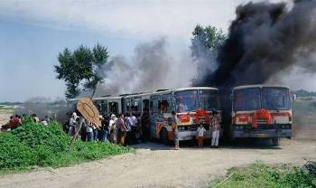 Art Express,120x200cm, 2002
In both art and economic fields, we see so much impact from foreign culture and residual influence from our own traditions. In "Art Express ", under the direction of so many famous international art biennales, people are so eager to get onto this Express Bus. Clearly visible on the panel are Venice Biennale, Documenta, Sao Paulo Biennale, Istanbul Biennial and etc. I create Qingsong Biennale, Songzhuang Biennale (Songzhuang is the artist colony in east Beijing), Biennale of Hell and Biennale of Heaven.

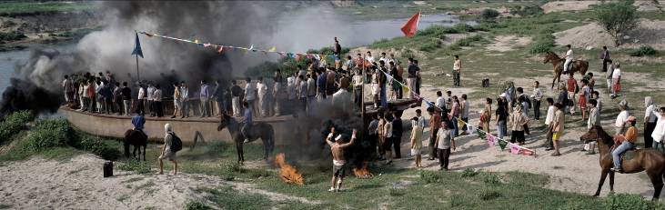 Port, 120x380cm, 2002
In "Port ", I shot the photograph with many people standing on or by the huge boat. There are a red flag, banner of the United Nations on the pole and many triangle banners with famous international commercial brands hinting at the victory of conquest. People look ahead while being surrounded by heavy dark smoke portending an unpredictable future.

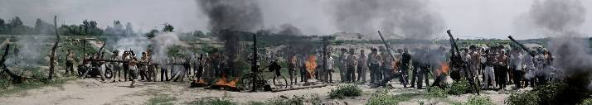 Sentry Post, 120x680cm, 2002
In "Sentry Post" where "refugees" try to push through the sentry post made of all famous foreign brand cans, I guard on close alert holding a coke can as a grenade. I created a barbed-wire border line hanging a lot of foreign products, looking like grenades, put them on fire, and prevent outsiders from coming into the city.

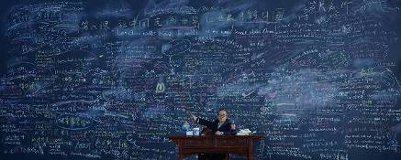 Follow Me, 120x300cm, 2003

“Follow Me” is the first English language-teaching program introduced by CCTV in 1982, the early times of economic reconstruction in China. This English-training series had sixty units, which were repeatedly shown for twelve years. It had 10 million viewers and sold over 30 million textbooks, setting a Guinness record for foreigners learning English. Many Chinese people got a glimpse of the western lifestyle from “Follow Me.” Farmers, workers, soldiers and students, even monks at Lama Temple, enjoyed watching the program which provided a window to learn what foreigners eat and wear and how they live. Many people consider “Follow Me” as the Bible for learning oral English. For example, one young soldier in Shenyang, Liaoning Province, was introduced to CCTV Headline News because he studied English so well. In the 1980s, “Follow Me” made it a reality for many people to go overseas. Its significance went far beyond learning English. It helped Chinese people to learn about the west and the world when just after China emerged from its closed-door policy.
In 1980s, I also liked watching “Follow Me” while studying in high school. However, I could never make it. Twenty years later, Chinese economic reform has brought a lot of dramatic changes. China has a lot of communications with many industries around the world. It will host the 2008 Olympics in Beijing and the 2010 World Expo in Shanghai. We seem to see China as communicating well with the world. However, I am still so backward, still failing to speak English. Such experiences inspired me to think of creating my photograph of “Follow Me”. On a huge four-meter wide and eight-meter long blackboard that I set up in Beijing Film Studio in 2003, many Chinese and English terms and sentences about changes in Chinese history and culture selected from English-training textbooks were scribbled in chalk. From the early TV series of “Follow Me” to my photograph “Follow Me”, it has been my dream to see “China Walks towards the World, and World Learns about China”.

Meat Flower series
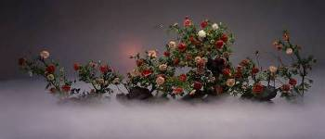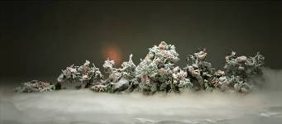
Ethereal Beauty and Auspicious Snow, 120x280cm, diptych, 280x120cm, 2003
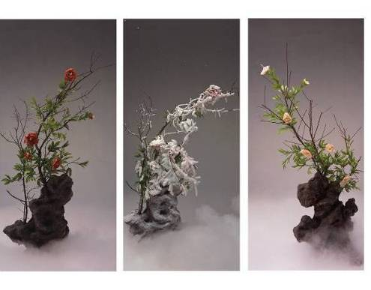
Red Peony, White Peony and Frosted Peony, 240x110cm, triptych

In the winter of 2003, I created a series of “fake flowers” series. The flower I chose is peony, symbolic of national brilliance and prosperity because peony is the national flower in China. I made the petals of peonies out of fresh veggie, lamb and beef slices. I shot one set when they are fresh. I reshot them after putting the peonies in deep frost for a week. This gives a transition from prosperity to decay and my hope to freeze such materialistic decadence made out of fleshy desires.

China Mansion, 120x1200cm, 2003

In summer 2003, I created China Mansion (120x1200cm). It was shot in a Beijing movie studio of more than 19,000 square feet. This studio formerly hosted important movie crews, including those for the model operas during the period of the Cultural Revolution and, recently, the Kill Bill crew. Currently the largest movie studio in China, it regrettably will be torn down to support commercially ambitious real-estate development projects.

China Mansion summarizes my perception of Chinese social reality during the current stage of globalization. China has been very enthusiastic about inviting foreign experts in economy, technology, architecture, and culture to give support and guidance to its modernization programs. These foreign specialists help to create economic opportunities and introduce alternative systems of thought to China. However, the cultural clash creates social contradictions. This phenomenon triggered me to shoot and direct China Mansion. In the set-up, I invited models to play the parts of foreign guests, mimicking postures in paintings by Ingres, Courbet, Manet, Gauguin, Klein, Boucher, Rembrandt, Rubens, Man Ray, and several other artists. I wanted my models to communicate with each other across centuries and with Chinese culture so as to create certain amiable relationships. It seems my hope was in vain. It’s easy to see that I play the role of the confusing host in this mansion, filled with both Chinese and western antiquities. Obviously the host is a conservative, but also a fashionista. On the left of the photograph, the host wears a banner of welcome. But on the right, the armed guard—like a terra-cotta soldier—looks like a robber, preventing the honorable guests from free movement and forcing them to leave something valuable in the host’s mansion.

Romantique
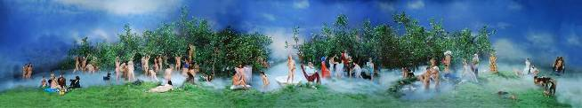 Romantique, 120x650cm, 2003

In Romantique, one seems to walk into a land that is half the heaven of western religion and half a pastoral Chinese garden. There are cheap plastic leaves, fruits, flowers, and decorations. The little ponds in this paradise emit a light smoke created from dry ice. Viewers can imagine false happiness in this fabricated beautiful paradise. Models act out the figures in western masterpieces by Massacio, Velasquez, Botticelli, Raphael, and Matisse. There’s a Chinese golden Buddha, beautiful princesses, and livestock. There’s a western girl and a Chinese man and his little girl, highlighting the potential conflicts of this complicated international dialogue. These people are very happy, peaceful, and without desire. Like “China Mansion”, the communication in “Romantique” is also forced, manufactured, chaotic and confusing in fabricated happiness in this man-made utopia. For me such fabricated ideal is like a daydream, a bubble.

Competition
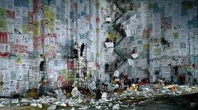 Competition,170x300cm, 2004
“Competition” (170x300cm, 2004) focuses on the power of ads and the misconceptions that ads can create. For this photo work, I constructed a chaotic backdrop where over 20 people are depicted in a frenzy of competition with some even fist fighting while jostling for ad positioning on a huge billboard advertisement; this struggle for the most optimal outdoor ad placement is perceived as inevitably bringing power and influence. The struggle for ad placement in public space in China is not unlike a battlefield strewn with casualties after a pitched battle for power. Today one brand wins. The next day, its competitor will replace it with better positioning on public spaces. Every day, new ads go up, and old ones fall down, scattered in pieces, and discarded on the ground under newly erected billboard advertisements.
In this work, I’ve constructed a huge wall, that stands about 14 meters high and 40 meters across, and I fixed over 600 pieces of paper (110x90cm each) on which I wrote in traditional Chinese ink brush style in some instances and in felt tip pen and magic marker in others, a random selection of slogans and phrases from the advertisements that bombard us here every day. These ads include both domestic and international information about companies and famous brands, such as the lease of houses, education programs, restaurants, foot massage, etc. Everything is advertised, from items as big as airplanes (BOEING) or as small as vinegar and condoms. On my gigantic wall, I make the fight for advertising as fierce as a struggle for military power, with inevitable casualties on the battlefield. I have also included some of the famous brands that proliferate in China, such as Shell, McDonald's, Durex, Starbuck's, along with a few of the anecdotes behind them and the misunderstandings that arise in translating these for a foreign audience. Altogether, I’ve used around 3000 varieties of products and services on my wall to show off the allure of this mass advertising campaign that surrounds us.
Billboard
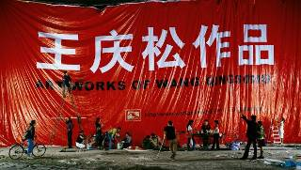 Billboard, 170x300cm, 2004
In terms of visual form and content, this outdoor advertising onslaught is not unlike the big character posters (“Da zi bao”) posted by competing factions and littering city streets in China during the Cultural Revolution. In the past the streets were hung with posters in fights over political beliefs. Now the struggle is over financial power and business gain. Ads for items are like psoriasis found everywhere on our city streets. This same theme has been followed by later projects, like “China Red’ (2009) and “Debacle” (2009) in the form of site-specific installation.
In “Billboard” (170x300cm, 2004), I continue my investigation of the power of ads and images. I reproduce a huge billboard that reads "Art Works of Wang Qingsong" in gigantic bold letters, in homage to the huge advertising signboards that line the second and third ring roads around Beijing. Life goes on, under the shadow of these huge billboards. We can see some passers-by reading these gigantic ads while others pay no attention at all. Instead, they play chess, buy vegetables, or otherwise carry on with their day-to-day activities. Do we recreate our lives to follow the images depicted in the ads? How much power do these words exert on our mind and eye? I am interested in this physical and mental space that lies somewhere in between advertisements and reality.

Archaeologist
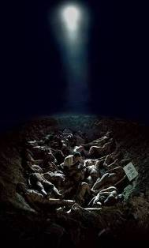 Archaeologist, 280x170cm, 2004

"Archaeologist" (280x170cm, 2004) was shot in a 3 meter and 8 meter big cave where 30 nude models covered with mud. It seems that they are remains from the long time ago. I act as the archaeologist and do the research on the remains to express my reflections on what is real and false in present-day times. For my personal feeling, I think the present-day human beings are dead in mind and soul whose remains need to be reexamined for the reasons for earlier death in this desires-infiltrating society.

Come! Come!
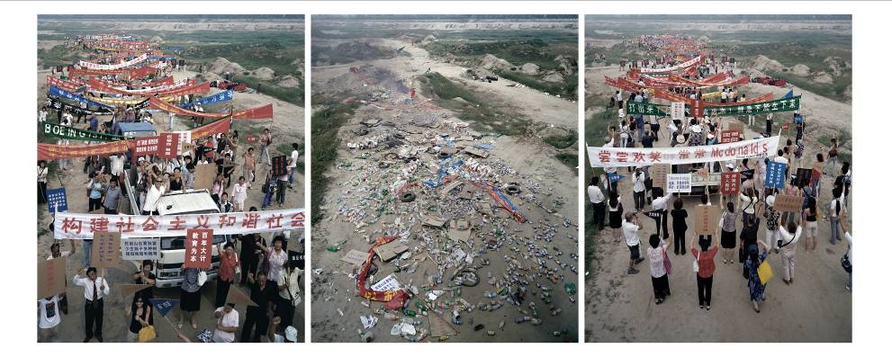 Come, Come, 200x170cm, 2005

In the summer of 2005, I made “Come! Come!” (170x200cm x 3 pieces). It involved 800 models, 5 props-moving trucks, 8 passenger buses, 5 trucks of garbage of all kinds, and nearly 40 assistants to finish. I chose a location for the shooting on the outskirts of Beijing, at the Hebei Province border, in a remote area where permitting and security issues could be avoided. The weather was perfect for the photo shoot since there was little sunlight. But the temperature was quite hot.

“Come! Come!” is a triptych color photo work shot from the same vantage point with the 8 by 10 large-format camera placed on a scaffolding nearly five meters above the ground. The triptych’s left panel comprises a frontal portrait of 800 “demonstrators” holding a sampling of historically significant slogans and banners, beginning with the Opium War of the 1840’s, (one of China’s first large-scale confrontations with the outside world) from the far back, all the way up to the present. These slogans and banners from recent events were chosen from a variety of historic books and records I’ve been reading over the last several months.

On the triptych’s right panel, the “demonstrators” hold slogans and banners from many of the best-known advertisements seen during the course of the Economic Reform period (1980’s to present). These include both local Chinese brands as well as many foreign brands. Together, the banners cover an interesting array of advertising concepts and slogans as well as a poignant record of the changing aspirations of a people over a course of time. The middle image in the triptych is one of a pile of debris scattered across an otherwise untouched landscape. The debris is comprised of the historical slogans, ads, banners, and daily garbage remaining after a large-scale event, a demonstration, or an act of historic significance.

The triptych gives the viewer three very different images of the same road and landscape. In this work, I use this outdoor landscape setting polluted by “demonstrators” to pose questions such as “What Is Coming?” “Who Is Coming?”, “How Does It Come?”, and “Why Is It Coming?”.... “Why Is It Happening On The Same Road?” Are the crowds generating slogans, garbage, or commercial advertisements? Historic changes of diverse impact often take place simultaneously, while seemingly going down one and the same path. But one thing is certain: The middle road, littered with garbage rather than people, appears silent, but one can see smoke and fire in the distance, hinting at some struggle, chaos, uncertainty or disputes either having come just before or just after the people.

Each of the images is shot using a wide-angle lens. I have deliberately cropped the people standing closest to the camera on the left hand panel without omitting them from the frame. On the right, I’ve let those tiny figures in the distance remain in the far corners of the shot. I mean to place history in the forefront and hint at the danger of allowing commercialism to get closer. My fear is that as commercialism (consumerism) moves ever closer, the risk of it overwhelming us and over-powering all that has gone before us gets bigger and bigger.

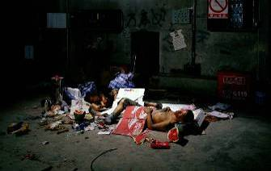 《流浪汉》，120x190cm,,2004
“Tramp” created in 2004 described a couple who loaf around the street. They seem to be full of aspirations for a wonderful future. Loitering around them are many redundant things, such as coins, discarded food and garbage. Of course one finds Sadam Hussein who was captured in the headline of New York Times. These minute but sensitive stories are taken to demonstrate the horrible life of the poor who wander on the street.

Home
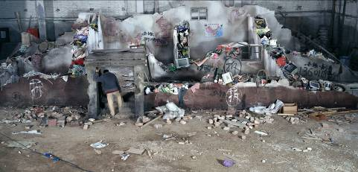 Home 120x250cm ,2005

In November 2005, I shot “Home”. It was inspired by my childhood memories from my family and movie scenes when adults often hid treasures into gaps in the wall. I was never able to make sense of it. So in my photograph, I set up a dilapidated house, only broken walls and all sorts of “treasures” opened from the gaps in the wall are visible. This demolished house has daily waste, computer screen and keyboard, books, newspapers, clothes and chemicals. Maybe these developers are helping me to unveil the confusion in my childhood. They demolish our houses and replace with high-rises because they know the values of the treasures in the wall and they are eager to pay a large price for developing such building projects.

Poisonous Spider
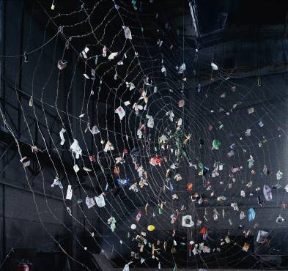 Poisonous Spide, 170x180cm, 2005
Spiders made out of barbed wires hint at the danger and attraction. This wire sticks onto its web a lot of garbage from consumer goods which I accumulated over half a year. Nowadays in this commercial world, everyone is like a spider which feeds itself with a variety of daily used stuff and some garbage and pursues for satisfaction of materialistic desires.

Dream of Migrants
Also I worked out an installation which turns into my work called “Dream of Migrants”. This term “Migrants” is very derogatory in China. It means aimlessly drifting population from one place to another, mostly from countryside to big cities to look for jobs. This group of people is called unauthorized flow of population. It hints at social instability. They are of special identity and marked with demean features as dirty, unstable and dangerous. In Beijing, there are nearly 3 million such people. They all hold a dream and look for opportunities when they flow from their hometown to big cities. They bring stimulus for urban development but also bring forth a lot of unstable factors, such as their children have no nice schooling and no stable housing. They used to be driven here and there due to lack of money and reputation. Many people take them as vibrant force but most people regard them as social virus. This derogatory term sometimes is mixed up with “Tramp, loafers, gangsters, rascals…”

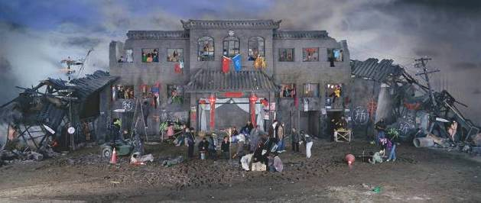 Dream of Migrants, 170x400cm, 2005

I am empathetic to this population. I think they hold onto their dear dreams and like to be recognized in the city and fulfill their values. But as a matter of fact, their dream is hard to realize with initial dream to be in conflict with their result. In 1993, I came to Beijing also from Jinzhou, Hubei Province. Jinzhou is a very small city. I also held deep dream and was surprised at the huge city of 100 times more of population than my hometown and the dramatic social changes in the urban cities. But I sustain because I know so many people like me flow into this city for the same ideal.

Dormitory
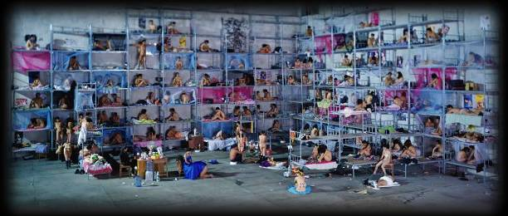 Dormitory, 170x400cm, 2005

In “Dormitory”, I like to express the pursuit for dream and opportunities in this bigger city.

The Glory of Hope
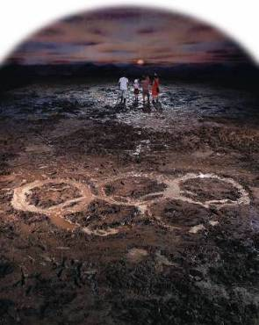 The Glory of Hope, 240x180cm, 2007
In 2007, I made “The Glory of Hope” and “UN Party”. “The Glory of Hope” goes back to the difficult past of China went through winning the right to host Olympics and an uncertain future under the canopy of a rainbow. The mire represents the reality of China being an agricultural country. The five figures in this photo are all my family members.

UN Party
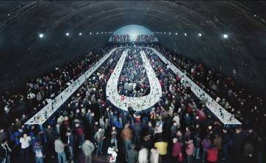 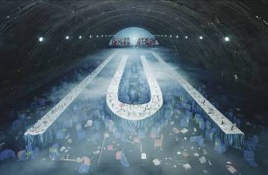 UN Party, diptych,170x280cm, diptych, 2007
“UN Party” refers to the globally popular gatherings, forums, conferences and dinners… In the left panel of this work, over 1300 people sat around U and N shaped tables and enjoyed cheap fast-food while entertaining heated discussions and expecting a bright future. However, in the right panel, all that remains are leftovers and a scene of chaos. The clouds of smoke overshadowing the black secretive place represent gloomy fantasy.

Gallery,
In May, 2008, I made a site-specific installation created with PKM Gallery Beijing space. The interior was wrapped up with the ubiquitous red, white and blue striped tart that blankets much of China’s evolving urban landscape, transforming the gallery into a circus-like construction site with a market sense of impermanence.
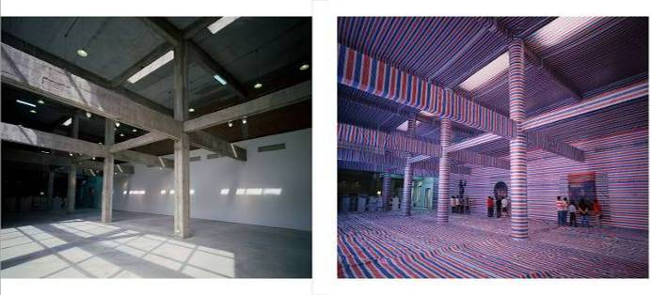 Gallery, 160x190cmx 2 pieces, 2008.

Hard-seat Compartment
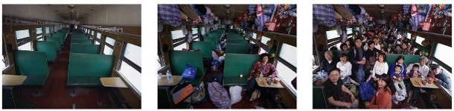 Hard-seat Compartment, 160x210cm x 3 pieces, 2008
“Hard-seat Compartment” a triptych that includes three photos: the first portrays a completely empty carriage; the second is a carriage with many luggage and a man, myself, sitting in front of a bowl of instant noodles and the third is train carriage crowded and filled up with passengers, luggage and bags. This work reveals different kinds of gloomy feelings in a busy and messy place. The audience reaction is a sort of claustrophobic impression. The “Hard-seat compartment” is a very common choice of transportation in China, these carriages are often crowded with passengers and luggage piled up in the most various and unsecured ways. Many people travel long distances and when they stop somewhere their unsettled and often depressing feelings still inhabit their hearts. The artist himself experienced many times these crazy trips when people were raking everywhere and chaos and annoyance used to make him feel bad and breathless. This work reflects the themes of journey and immigration and what people are able to do and tolerate in order to move and improve their lives.

Nutrients
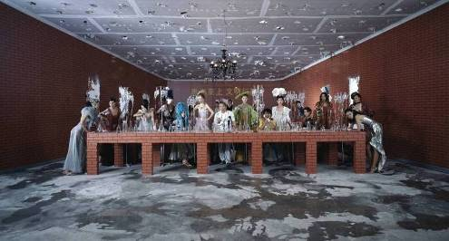 Nutrients, 160x300cm, 2008
I have observed the scenes in hospitals for many years. These experiences come from my own family member, me, and other friends. There are a quite small percentage of people who hold government or corporation positions can get reimbursed from the cost of hospitalization. However, a large majority of the people in China have to pay money ahead of time due to lack of wide-spread social medical care. My son had been to hospital for a check-up. The doctor told him to be quite when he was only three years old when he was so afraid of doctors. My mother died of cancer and was refused to stay further in the hospital for treatment due to lack of money. I myself was treated badly staying in a ward where an old man died and his relatives cried for a whole day in front of the dead body. Many friends said similar experiences. We call for the conscience and conscientiousness from the whole hospital staff. There is no nice response back..

Temporary Ward
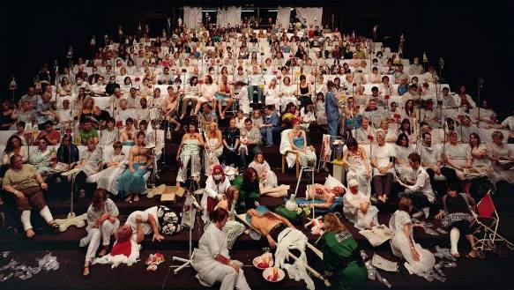 Temporary Ward, 180x320cm, light-box, 2008
I have been thinking of making a photo about hospitals and patients. When I was invited to the Northern Stage, New Castle, UK, to do a theatre project, I found out people came to theatres for psychological well-being, similar to the request for physical health when patients come to the hospital. Do they get any real treatment or not, either from theatres or hospitals? With this question in mind, I come to the idea of transforming Northern Theatre into a hospital ward. Stage one is the appropriate place to house 300 patients, medical staff and other participants. On September 13, 2008, with the full support of Northern Stage staff and 300 volunteers, this project was successfully realized.

Debacle
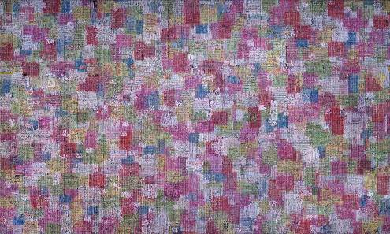 Debacle, 170x300cm, 2009
I have been thinking about how both commerce and humankind fail though humankind produce merchandise which comes back to dominate humankind conversely. The dilemma to answer this question will come to a philosophical inquiry if the world is what we make or we are what the world makes.
From October 2008 to January 2009, I worked on the several-fold meanings of “international brand names” which we fabricate for commercial promotions. I collected all sorts of advertisements from real objects such as soft drink bottles, boxes and containers for products, medicine, as well as paper advertisements from newspapers, magazines, and invitations worldwide. Then I reproduced them in hand-writing into 3,000 pieces of paper sized 85x110cm each and glued them onto rippled asbestos tile sized 75x200cm layer by layer. Within seven days, we scratched off the layers of layers of commercials and mounted them onto a 12 meter high and 25 meter long setting of broken, worn-out, dilapidated-looking abandoned wall.
When these asbestos tile covered with broken strips from commercials are put side by side, one finds them so eye-catching as if they are an abstract painting. This process of production and destruction is like a game of building blocks. We like to build up something new and then we must destroy it for a brand-new style again. What a dilemma!

Video Works

Skyscraper, 5 minutes, 35 mm film, 2008

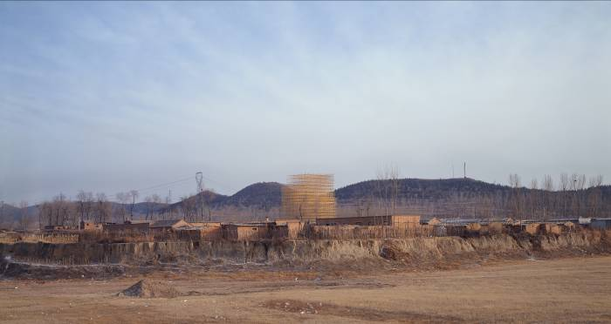

The marvelous installation is about 35 meters high, with a diameter of 45 meters, built by 40 workers within a month or so in Changping County, 30 miles north of Beijing. The scaffolding iron bars are painted with gold color to make them look shiny and golden under the sunshine. This golden scaffolding signifies the glory/wonder of drastic changes in urbanization drive. The soundtrack dubbed at the end of “Silent Night” melody together with colorful fireworks celebrating the Chinese New Year creates a very peaceful while melancholy world.

Through this video piece, I want to analyze how dramatic social changes, in particular, in terms of skyscrapers, happen in China and how it has nothing to do with humanity. I chose this location and accidentally found this poor village has been contaminated with pollution resulting in deformities of children. Like what is described in my photo works, I have been quite skeptical of such dramatic transformations which involve human intervention but are not human-friendly. This “Skyscraper” is like a Greek genie that grows from a smoky ground and pops up drastically. The whole process of this scaffolding construction emulates the process of beginning to end construction of a potential building.
Working of the film
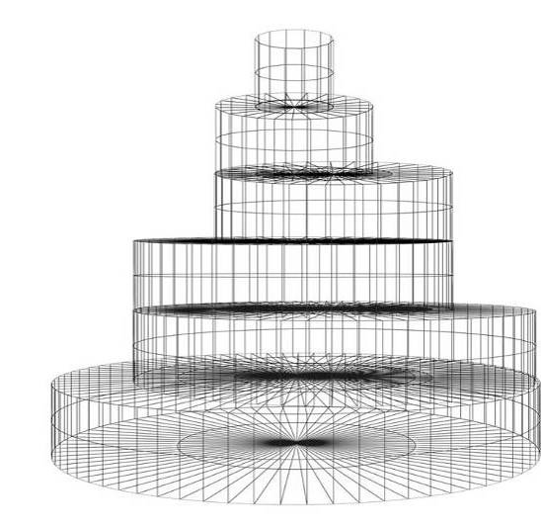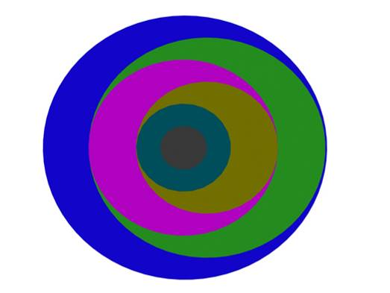
“Skyscraper” – sketch 01 Upper view

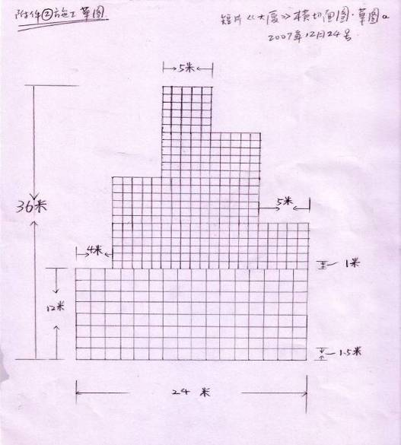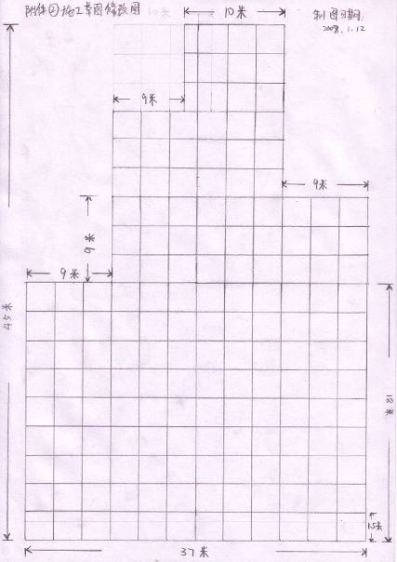
Draft 1: 30m in diameter, 36m in height Draft 2: 37m in diameter, 45m in height
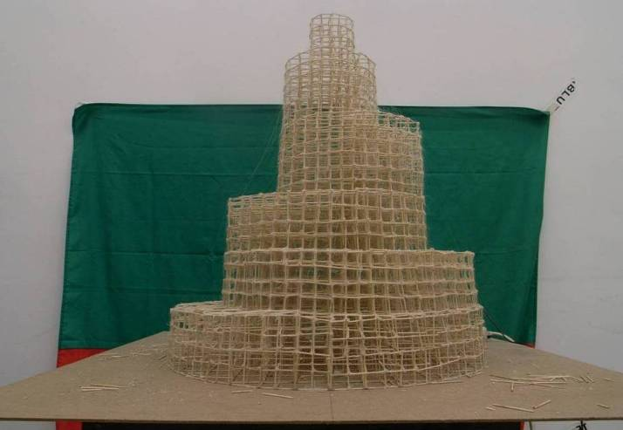
Marquette with tooth-picks, December 2007

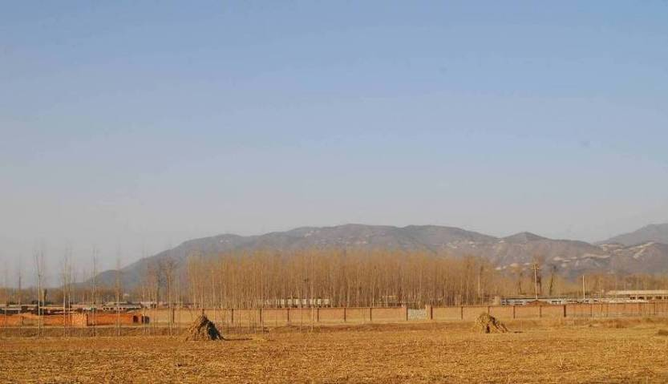
Shooting location, village in Changping District, Beijing. January 2008

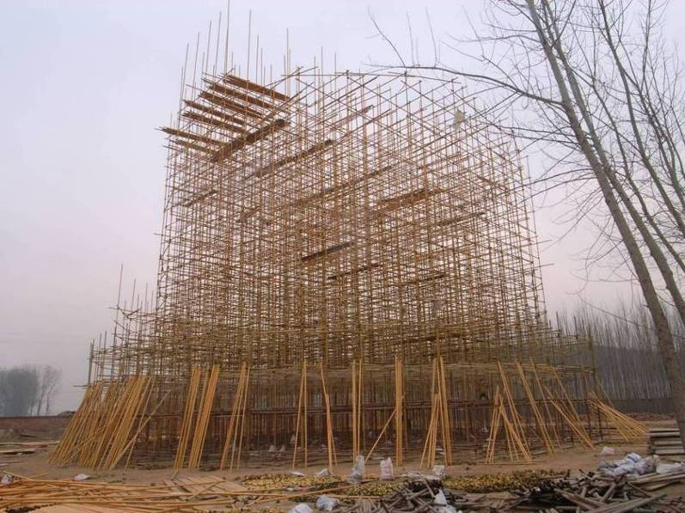
Front view of 24 meter high

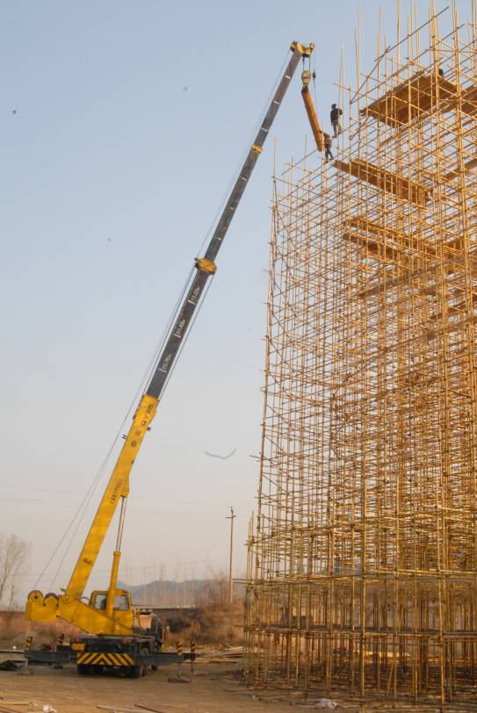
Construction site, Changping County, Beijing

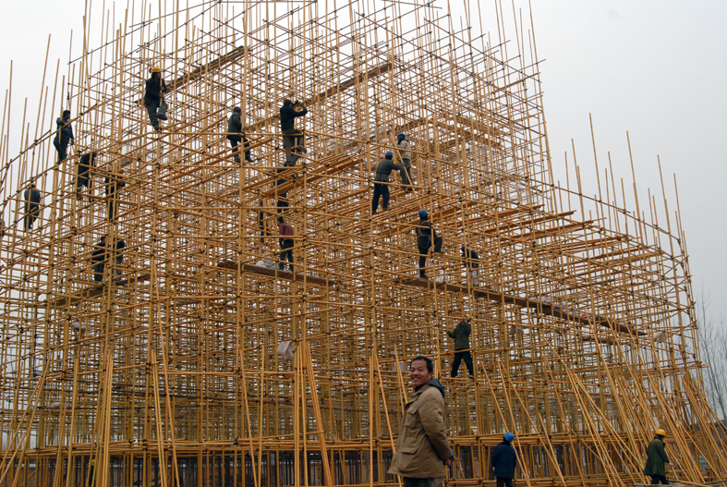

“Iron Man”, 4 minutes, 35 mm film, 2008

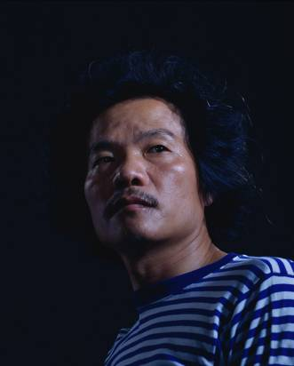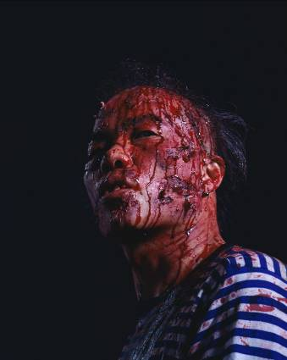

A poster from the Cultural Revolution entitled “To live like such a person” refers to the appreciation of being a brave, honest, and heroic person. In our childhood, we have been taught how to live and why to live in politic classes. So such a hero is supposed to be a great model to live up to when we grow up.

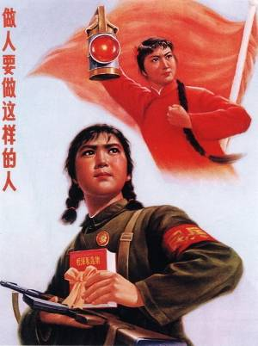

However, the real world is very tough, stifled with conflict, war, violence, strife, controversy, fight, combat… People have to face up to all these severe situations. To be hero means a lot of suffering, bravery, insistence, all sorts of skills of stamina to combat against the unexpected disasters.

In this short film, Wang Qingsong created a hero in his own image called “Iron Man”. This term “Iron Man” refers to an oil worker (Qingsong used to work in the oil-field for over eight years) who dedicated his life to developing Chinese oil industry in early 1960s. In this film this strong-minded hero has been beaten up by a lot of fists but always straightens up his head facing sideways as if “taking death as going back home”. He avoids the fist by playing Chinese “Tai Chi” (a Chinese body-exercise system of slow meditative physical exercise designed for relaxation and balance and health). Finally, though hair and teeth losing, he still smiles at his opponents. Is it a fact of life or ridicule about all sorts of violence? Or what is it?

123456 Chops, 4 minutes, video, 2008

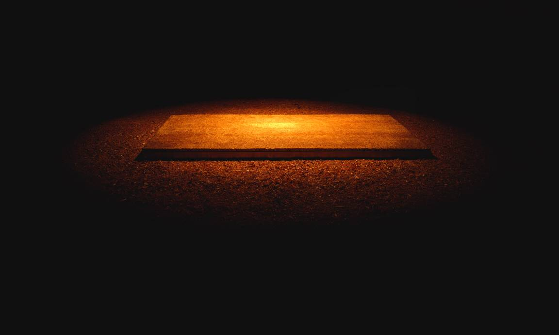

In deep light, a man dressed like a lunatic or a patient come to the huge chop board and threw off a dead goat. Then he wildly cut it into pieces hour by hour, day by night. His anger, violence, suffocation, sadness, disappointment, are all contributed to making this film a disturbing piece in that people cannot understand if ventilation of anger, hatred, self-defense, or other negative feelings is a way to relieve oneself of such mental diseases.

An episode off this film happened very sarcastically when the artist tried to buy a pair of big-bladed machetes from kitchenware shops. They all looked at his very suspiciously and watched out him from far away. Either they told him there were no such hacking knives, or three or four people came together to be on guard against him. He must be taken as a sick person or dangerous crazy guy in some ways. In this sense, life is full of dangers, terrors, violence, insecurities, suspicions, and etc…

